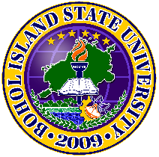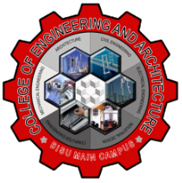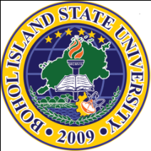Republic of the Philippines

**BOHOL ISLAND STATE UNIVERSITY**

**MAIN CAMPUS**

Tel: 038-4113289 Telfax: 038-5017516 

6300 Tagbilaran City

Vision: A premier S&T university for the formation of world class and virtuous human resource for sustainable development in Bohol and the Country.

Mission: BISU is committed to provide quality higher education in the arts and sciences, as well as in the professional and technological fields;

undertake research and development, and extension services for the sustainable development of Bohol and the country.

**Project #1-M**

**CpE 311 –** Computer System Organization with Assembly Language

**Unblock The King (Game)**

Submitted by:

Perin, Max Angelo D.

Submitted to:

Engr. Jeralyn Alagon